**WiselyMe - Your Intelligent Personal Financial Wellness Companion**

**January 2024, By Ranjithkumar S**

Abstract - Prototype Selection:

Implementing an AI-based financial wellness project is crucial for its ability to deliver highly personalized advice, analyze real-time data for timely insights, and adapt continuously to users' financial journeys. The engaging nature of an AI chatbot fosters active user participation, while its comprehensive coverage of financial aspects addresses diverse user needs. Strategic partnerships with financial institutions and integration with banking apps enhance the ecosystem, and the scalability ensures accessibility to a broad audience. Robust security measures safeguard users' financial data, and behavioral economics principles contribute to improved financial literacy. Embracing AI keeps the project at the forefront of technological advancements, ensuring ongoing relevance in the dynamic financial industry.

Problem Statement:

Current financial tools fall short in providing personalized insights and timely advice, leaving individuals struggling to navigate complex financial landscapes. Limited user engagement, coupled with concerns about data security, creates obstacles in fostering trust in digital financial platforms. There is a critical need for an AI-driven financial wellness solution that offers personalized guidance, promotes active user participation, and ensures robust data security, empowering individuals to navigate their financial journeys confidently.

Market Dynamics Evaluation:

The market and customer need for an AI-driven financial wellness solution are evident in the growing demand for personalized and adaptive tools in the personal finance sector. Individuals today seek more than traditional financial platforms can offer, desiring tailored insights, timely advice, and engaging experiences to navigate their financial landscapes effectively. The rising complexity of financial decision-making further underscores the necessity for a comprehensive solution. Moreover, users prioritize platforms that prioritize data security and privacy, reflecting a critical business need. Addressing these market demands through an innovative AI-driven financial wellness platform not only satisfies consumer expectations but also positions the business to capture a significant market share in the evolving landscape of digital financial services.

Target Profiling:

**User Demographics, Geographic Focus, and Financial Behavior:**

Our target users, aged 25-45, predominantly encompass middle to upper-middle income individuals with a college education, representing diverse professional backgrounds including technology, finance, and entrepreneurship. This demographic seeks personalized financial advice, demonstrating an interest in optimizing budgeting, saving, and investing. Geographically, we initially concentrate on urban and suburban areas with a tech-savvy population. These users, comfortable with mobile apps and online tools, exhibit moderate to high digital literacy and prefer interactive, conversational interfaces. Importantly, our platform addresses data security concerns by implementing advanced encryption and authentication protocols, providing peace of mind to privacy-conscious users. Our monetization strategy focuses on a subscription-based model for premium features, potential partnerships with financial institutions, and integration with banking apps, ensuring a comprehensive and tailored financial experience for our target audience.

**Technological Proficiency, Engagement Preferences, Data Security:**

Our target users demonstrate a strong technological proficiency, comprising individuals comfortable with mobile apps and online tools, showcasing a moderate to high level of digital literacy. Their engagement preferences lean towards interactive and conversational interfaces, reflecting a desire for user-friendly and engaging financial platforms. Furthermore, these users prioritize data security, expressing concerns about the privacy of their financial information. To address these apprehensions, our platform is committed to implementing advanced encryption and authentication protocols, ensuring a secure and trustworthy environment for users to manage their financial well-being.

**Dataset:**

The 2017 National Financial Well-Being in America Survey, conducted for the CFPB Offices of Financial Education and Financial Protection for Older Americans, was an online survey conducted to measure the financial well-being of adults in the United States. These data were created as a foundation for internal and external research into financial well-being and are relevant to work being done by researchers in the Office of Research who have access to the (deidentified) data.

* [Financial Well-Being in America (2017) - Catalog (data.gov)](https://catalog.data.gov/dataset/financial-well-being-in-america-2017)

Github link - [Intership-Feynn-Labs-/Project #3 at main · Ranjithkumar21s/Intership-Feynn-Labs- (github.com)](https://github.com/Ranjithkumar21s/Intership-Feynn-Labs-/tree/main/Project%20%233)

**Column Selection and Renaming:**

The DataFrame df is filtered to include only specific columns of interest related to financial well-being, employment, and various financial products.

**Columns are renamed for better comprehension.**

**Checking and Handling Missing/Junk Values:**

The code checks for the presence of junk values (-1, -4, 99) in specific columns and prints their counts.

Rows containing these junk values are then removed from the DataFrame.

**Relabeling Categorical Variables:**

Categorical variables such as employment, education, and income are relabeled for better readability.

**Exploratory Data Analysis (EDA):**

Numerical and categorical columns are separated into two DataFrames, df_num and df_cat.

Histograms are created for numerical variables, and bar charts are created for categorical variables using Matplotlib and Seaborn.

**Creating Dummy Variables:**

Dummy variables are created for the categorical columns (employment and education) and added to the original DataFrame.

**Pivot Tables for Initial Understanding:**

Pivot tables are created to analyze the impact of different financial products on financial well-being. It calculates mean and median values for financial well-being based on the presence or absence of each financial product.

**Model Building (Univariate Regression):**

Packages like Statsmodels are imported for statistical analysis.

Univariate regression models are run for each financial product separately, with financial well-being as the dependent variable.

The R-squared values (a measure of how well the independent variable explains the variation in the dependent variable) for each regression are printed.

**Summary:**

The code provides a comprehensive overview of the dataset, handles missing or junk values, explores data distribution, and builds univariate regression models to understand the impact of individual financial products on financial well-being.

**Business Opportunity:**

**Financial Wellness Platform:**

Service Offering: Launch a user-friendly financial wellness platform that incorporates the predictive model to assess users' financial health.

Features: Provide personalized budgeting, savings, and investment recommendations based on the predictive analysis.

User Engagement: Implement interactive interfaces to engage users actively in their financial planning.

**Subscription-Based Model:**

Monetization Strategy: Offer a subscription-based model for premium features, granting users access to advanced analytics, real-time financial insights, and additional personalized recommendations.

Tiered Plans: Introduce tiered subscription plans to cater to different user needs and financial complexities.

**Model Deployment:**

**Concept Definition and Value Proposition:**

Clearly articulate the purpose and value proposition of your financial wellness platform, emphasizing the use of a predictive model to enhance user financial well-being.

**Target Demographic and Key Features:**

Define the specific characteristics of your target demographic, such as age, income, and profession.

Identify key features based on the predictive model, including personalized budgeting, savings recommendations, and interactive financial planning tools.

**Monetization, Security, and Technology:**

Develop a clear monetization strategy, considering subscription plans, freemium models, or partnership-based revenue streams.

Outline security measures to address user data concerns and ensure compliance with relevant regulations.

Decide on the technology stack for platform development, considering web-based applications, mobile apps, or both.

**Marketing and User Acquisition:**

Create a comprehensive marketing strategy to acquire users, utilizing channels like social media, influencers, and digital advertising.

Consider educational content and community building within the platform to enhance user engagement.

**Testing, Iteration, and Launch Strategy:**

Develop a testing plan to ensure the reliability of the predictive model and implement quality assurance processes.

Establish mechanisms for collecting user feedback and plan for iterative development based on insights.

Develop a phased launch strategy, including beta testing and refinement before a full-scale launch. Leverage initial user feedback to make necessary improvements.

Final Product Prototype/ Product Details:

To create a predictive model for financial wellness, We can use a linear regression formula, as it's a common and straightforward method. The formula for a simple linear regression is:

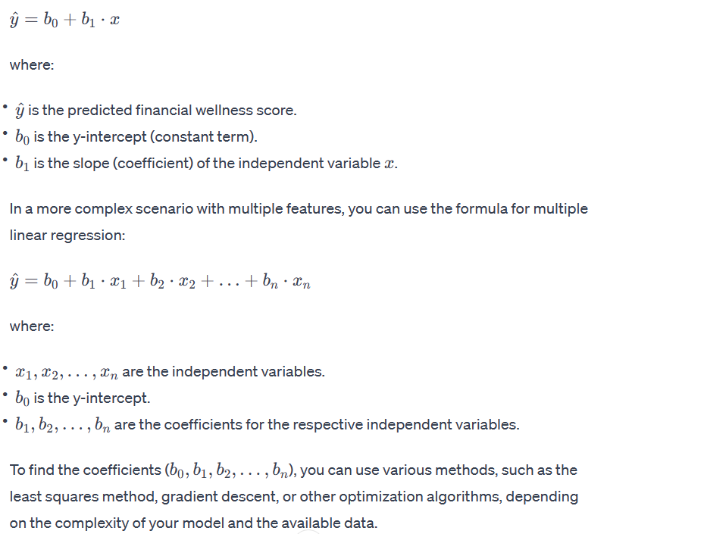

Consultation:

In closing, our financial wellness platform represents a transformative solution, uniting cutting-edge technology and user-centric design to empower individuals on their financial journeys. By leveraging the predictive model, we aim to redefine the way users approach budgeting, savings, and investments, providing personalized and actionable insights. As we embark on this exciting venture, we are committed to fostering a community where financial well-being is not just a goal but a tangible reality. Through continuous innovation, strategic partnerships, and a dedication to user feedback, we aspire to make a lasting impact, helping individuals achieve their financial goals with confidence and ease. Together, let's shape a future where financial wellness is accessible, engaging, and tailored to each individual's unique aspirations.